NAME
SUBJECT: BASIC TECHNOLOGY |  | CLASs: J.S.S.1 | DURATION: 1 ½ HOURS
INSTRUCTION: This paper consists of two sections. Answer ALL questions on section A and FOUR questions on section B (Question one is compulsory)
SECTION A: Objective (20 marks)

- The small box used for keeping tools is known as ………………………
- tools rack
- tools box
- tools shelf
- tools cabinet
- The types of building based on design include the following EXCEPT.
- round house
- flats house
- stone house
- skyscraper
- The following are examples of boring tools EXCEPT ……………..
- brace
- bradawl
- twist drill
- keyhole
- A wooden saw should be care for in the following ways EXCEPT…………………..
- keep in cool dry place
- sharpen when dull
- hang in free space or without obstruction
- not putting oil on the blade.
- Which of the materials is NOT used in technology as material used for technical products?
- Wood
- Ceramics
- Metal
- internet
- The following are measuring tools EXCEPT ………
- micro screw gauge
- depth gauge
- surface plate
- tape rule
- The following are marking out tools EXCEPT …………….
- punches
- scriber
- odd leg caliper
- divider
- The following are holding tools EXCEPT …………………
- bench vice
- G- clamp
- plier
- venier caliper
- Which of the following is the metal worker pencil?
- Divider
- Punches
- Scriber
- Hammer
- Which of the following is not a driving tool?
- Hammer
- Screwdriver
- Brace
- punch
- One of the following is used for removing imperfection from a finished surface.
- chisel
- saw
- scrapper
- file
- The type of circuit shown below is
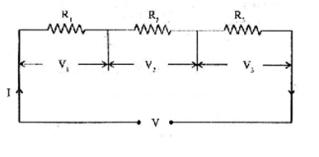
- series
- parallel
- closed
- open
- An atom comprises of proton and neutron in the nucleus and ………. In orbits.
- elements
- electrons
- positive charges
- particle
- Electricity is energy from …………..
- solar
- charge particles
- nuclear
- wind.
- The tool used for driving bolt and nut is
- wrenches
- pliers
- screwdriver
- stripper
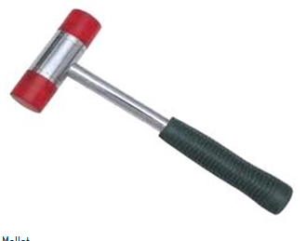
- The figure below is …………….

- mallet
- ball pein hammer
- special hammer
- sledge hammer
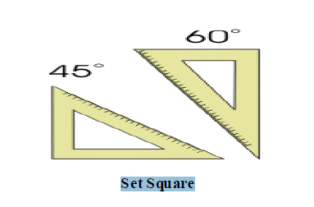
- The drawing instrument shown below is….

- set square
- try square
- tee square
- french curve.
- Which of the following is not a grade of file?
- Rough grade
- Bastard grade
- Second grade
- Fine grade.
- Which of the following hammer is used for riveting in metalwork?
- Ball pein hammer
- Cross pein hammer
- Straight pein hammer
- Special hammer
- A room, especially one which is not particularly large, used for manufacturing or other light industrial work is called.
  - a workshop
  - a shop
  - a laboratory
  - a school.
- An unexpected event with negative consequences occurring without the intention of the one suffering the consequences is called.
  - injury
  - accident
  - victim
  - safety.
- Which of the following is not a safety device?
  - Protective clothing
  - Goggle
  - Safety shoes
  - Slippers
- The act of removing and replacing faulty parts is known as ………
- maintenance
- overhauling
- repair
- servicing
- The process of prolong the time a system function is known as ……….
- maintenance
- overhauling
- repair
- routine maintenance
- The best form of maintenance is ………….
- predictive maintenance
- preventive maintenance
- corrective maintenance
- repair
- The book of instructions and information about a machine is known as ……..
- collections
- catalogue
- manual
- book
- The formula for calculating power in a circuit is
- IR
- I²R
- ER
- V/R
- The instrument used to measure potential differences is.
- voltmeter
- ammeter
- potentio meter
- watt meter
- The formula for calculating total resistance in a series circuit is.
- R_{T} = R₁ + R₂ + R₃
- R = $\frac{1}{R}$ + $\frac{1}{R }$ + $\frac{1}{R}$
- $\frac{1}{R}$ = $\frac{1}{R}$ + $\frac{1}{R }$ + $\frac{1}{R}$
- $R=R$
- Which of the following is not a basic quantity in electricity
- volt
- resistance
- current
- oxidation
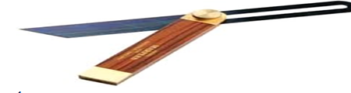
- The figure below is a …… in woodwork hand tools.
- bevel gauage
- deluxe gauge
- sliding gauge
- mortise gauge.
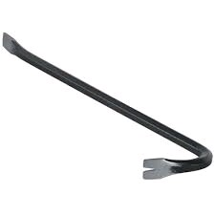
- The figure shown below is ……

- crowbar
- lever bar
- push rod
- mortar
- One of the following is an instrument used to measure many variables.
- voltmeter
- ammeter
- multimeter
- potentio meter
- The following tools are used for maintenance EXCEPT …………
- manual
- tester
- hammer
- catalogue
- The gap between capacitors plate is called
- electric
- Dielectric
- capacitance
- pole
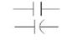
- The symbol shown below represent …..

- cell
- switch
- capacitor
- transistor
- Capacitor CANNOT be used in one of the following ….
- air condition
- electric motor
- boiling ring
- television
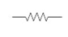
- The symbol shown below is ………….

- resistor
- switch
- electric bulb
- earth
- The electrical device that gives constant output for variable input voltage range is …..
- transformer
- stabilizer
- electric motor
- Inductor
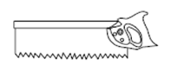
- The type of wooden saw shown below is …

- rip saw
- cross cut saw
- tenon saw
- band saw
- The maintenance of faulty/ nonfunctioning radio is …….
- predictive
- preventive
- corrective
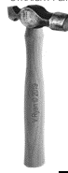
- routine
- The metalwork handtools shown below is.

- ball pein hammer
- block hammer
- sledge hammer
- straight pein hammer
- The metalwork handtools shown below is …
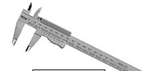
- odd leg caliper
- veneir caliper
- inside caliper

- outside caliper
- The metal work tools shown bellow is …..

- wrench
- punch
- screwdriver
- gimlet
- Which of the following is not electrical material?
- Conductor
- Insulator
- Semiconductor
- Water
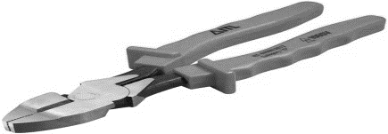
- The electrical tool shown below is …..

- general pliers
- clip pliers
- long nose pliers
- gripping pliers
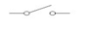
- The electrical symbol below represent …..

- resistor
- conductor
- fuse
- switch

- The electrical symbol below is ……

- switch
- inductor
- transformer
- electric motor
- The current in the circuit below is ………
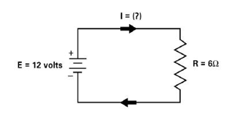
- 3 amperes
- 2 amperes
- 4 amperes
- 2.5 amperes
- The figure below is an example of a/an ……….
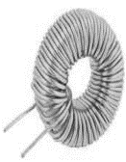
- transformer
- capacitor
- resistor
- inductor

SECTION B {40 marks}
Instruction: i. Answer FOUR questions from this section, question ONE is compulsory and any other THREE.
ii. Use all necessary drawing instruments and materials where applicable.
iii. Credit will be awarded for neatness and accuracy
iv. Use pencil for all construction questions

- A. Draw boarder lines and title block, fill in your name, school, class, subject and date (4 marks)
B. Draw with free hand sketching of six woodwork driving tools. (6 marks) C. Draw with free hand sketching six metalwork measuring hand tools. (6 marks)

2. A. List four woodwork holding tools (2 marks)
B. List four care and maintenance for woodwork hand tools (2 marks)
C. Define the following i. electricity ii. Circuit iii current iv. driving tools (2 marks)
D. Fill in the gaps in the table below. (2 marks)
S/N | INSTRUMENTS | SYMBOLS | QUANTITY
1 | Ammeter |  | Current
2 | Voltmeter
3 | Wattmeter |  | Watt/power

3. (A) Identify four woodwork cutting handtools with aid of small diagrams. (2 marks)
(B). List and explain types of maintenance briefly. (2 marks)
(C) Calculate the total resistance and current in circuits shown below.
I II
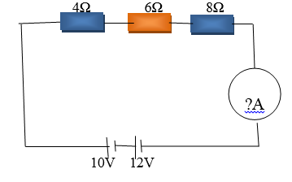 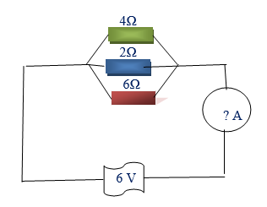 (4 marks) 4. . (A) Define the following i. cutting tools, ii. Electromotive force (emf), iii. Cell iv.current (2 marks)
(B) Calculate the voltage in circuits shown below (2 marks)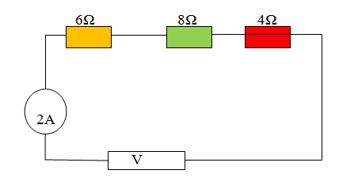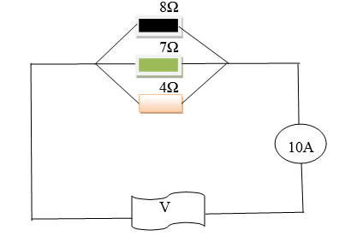
(C) Define the followingi. site preparation ii. Grubbing iii. Setting out iv. Dewatering (2 marks)
(D) Write names of electrical devices shown below in the box provided. (2 marks)
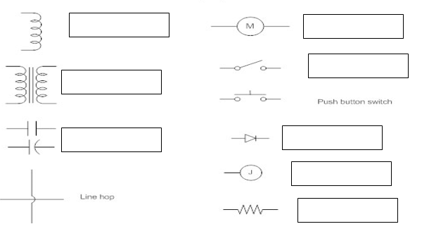

5. (A) List four safety precaution for handling woodwork hand tools. (2 marks)
(B) State four effect of electricity. (2 marks)
(C) List four safety precautions taken on metalwork handtools. (2 marks)
(D) List four types of magnets. (2 marks)

